- Account Information
  - Username & Password

You may login from the main website with the credentials you were issued


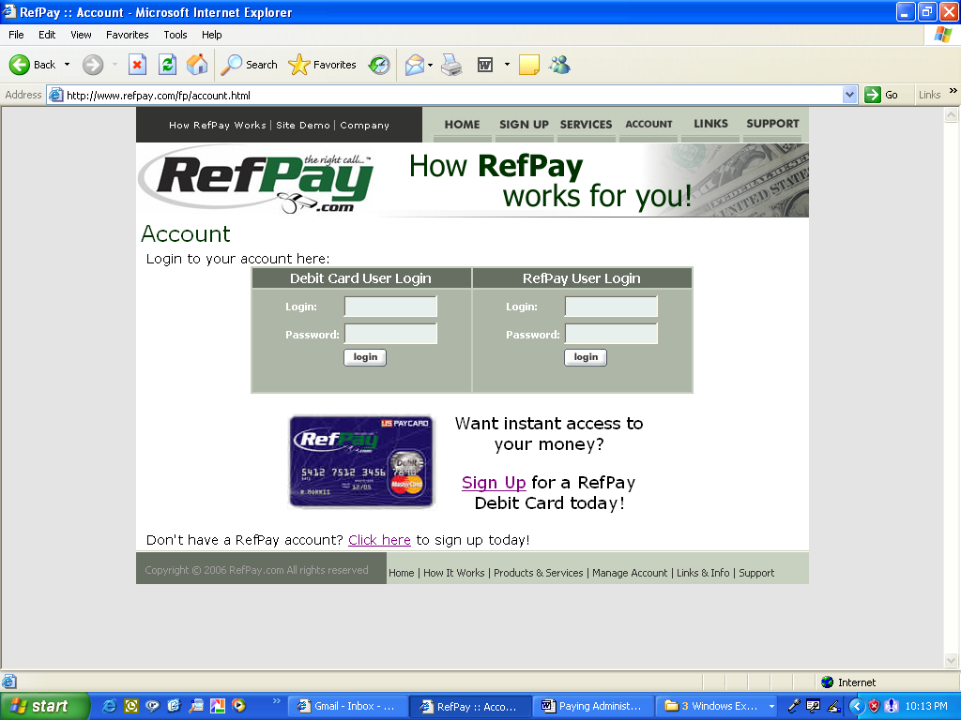
OR

Each Official has a unique Username and Password.

  - Security Key

Security Key’s are similar to PIN numbers for debit cards. Every Official has a unique Security Key. In order for a transaction to be approved, Security Key’s are required to be entered anytime money is transferred into or out of a RefPay account. *Make sure you remember your Security Key as it will only be given once through the messaging system.

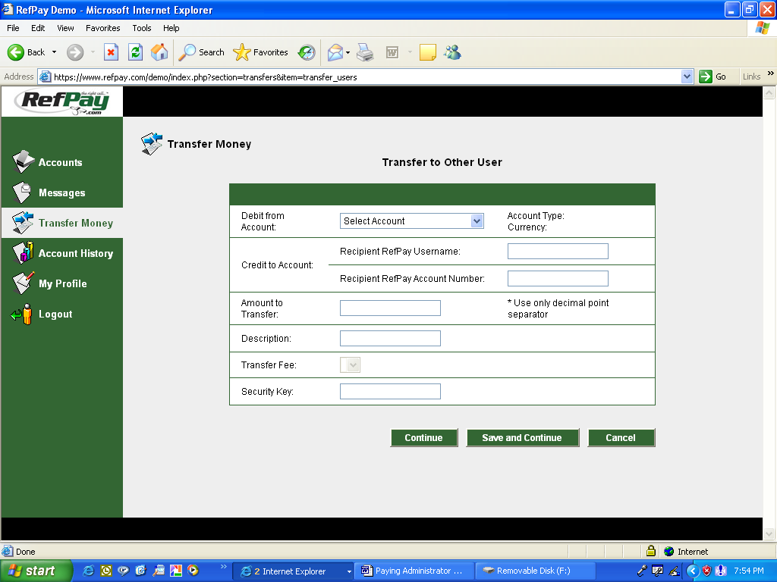
You will get an error message without the proper Security Key.

  - Account Number

Each Official has a unique account number. Account numbers are 10 digits long. Paying Administrators accounts begin with a 0 and Officials accounts begin with a 1.
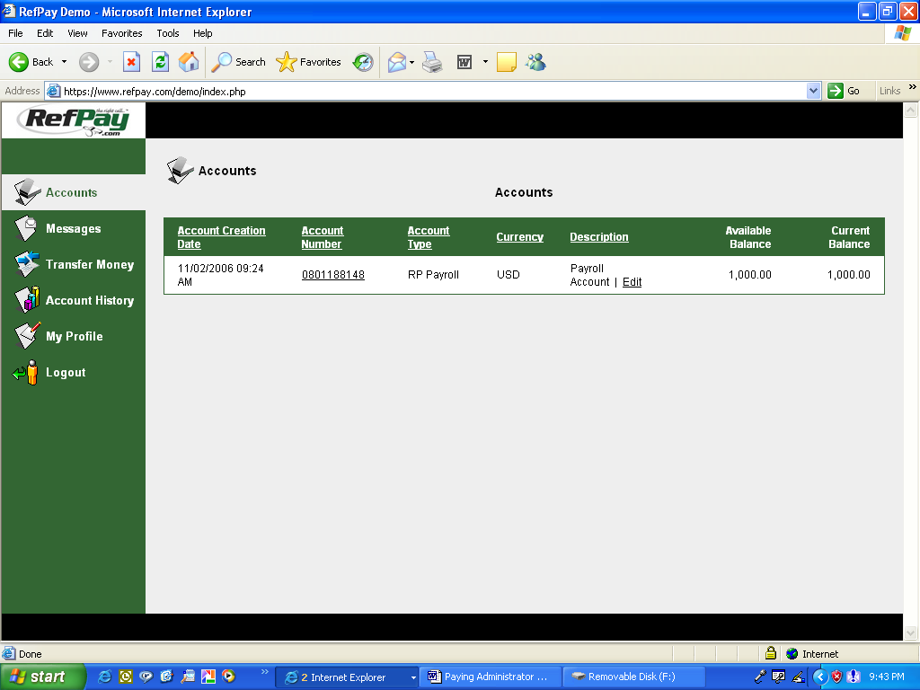
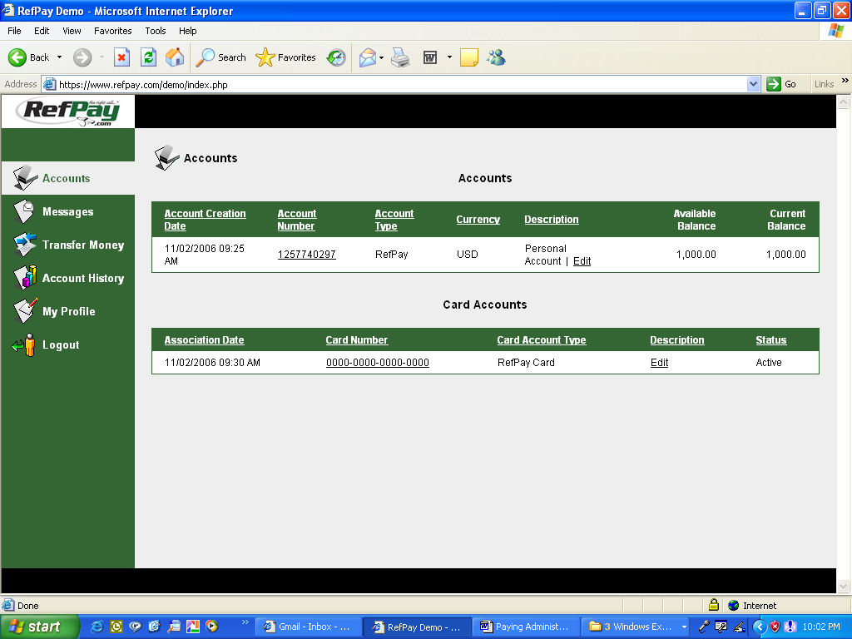

Account Numbers are 10 digits long. Paying Administrator’s accounts begin with a 0.
Official’s accounts begin with a 1

  - Available Balance vs. Current Balance

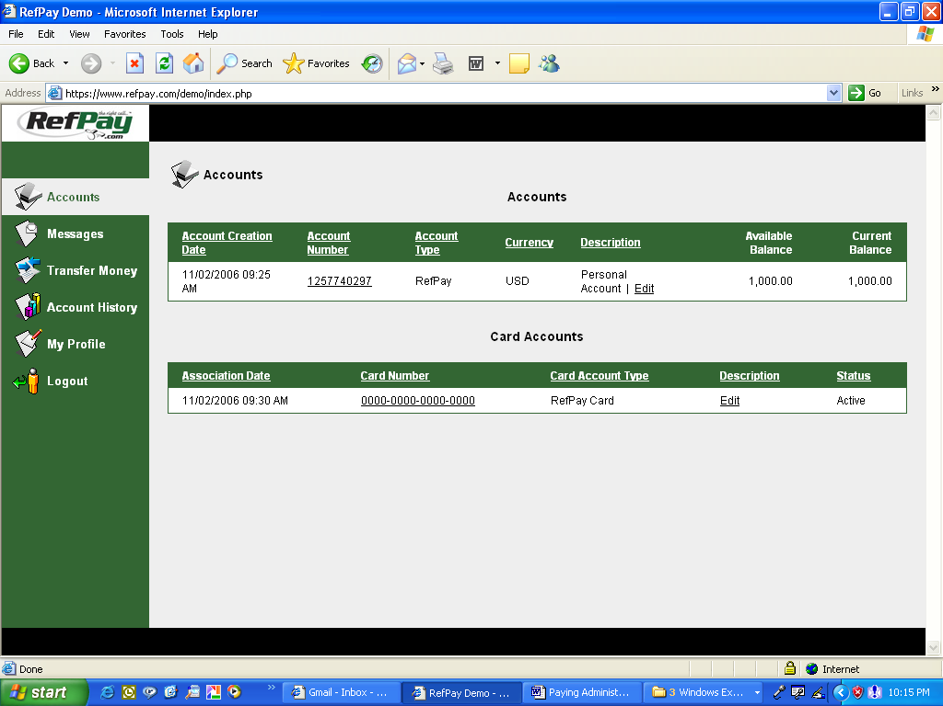
Available balance is the money you can access immediately. Current balance reflects money you can access plus or minus any credits or debits not fully collected. In most instances these numbers will be the same. However, it’s important to remember ACH debits and credits take 2 – 4 business days to be fully collected.
Available Balance and Current Balance may differ because ACH funds have not been fully collected.

  - Multiple RefPay Accounts

RefPay allows users to have multiple RefPay Accounts if they desire. This function was designed specifically for users who want to keep money and/or earning’s separate. An Official may use this function to keep money earned officiating Basketball in one account and money earned officiating Soccer in another account.
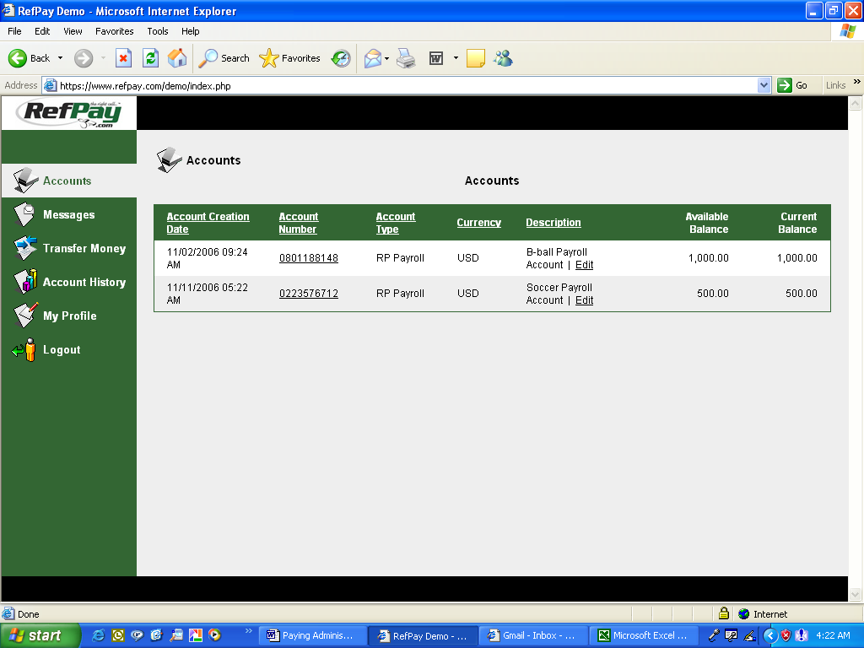
User’s can have multiple RefPay accounts if they want to keep money and/or earning’s separate.

- Message System
  - Purpose of Message System

RefPay has an internal messaging system that allows you to communicate directly with the RefPay administrator. This system can only be accessed when you are logged in with your unique user ID and password. The quickest way to resolve any problems that may arise is by communication through the messaging system.

3.2 Sending a Message

Sending a message to the RefPay Administrator is easy. Click on the Messages Tab, then on the New Message icon.
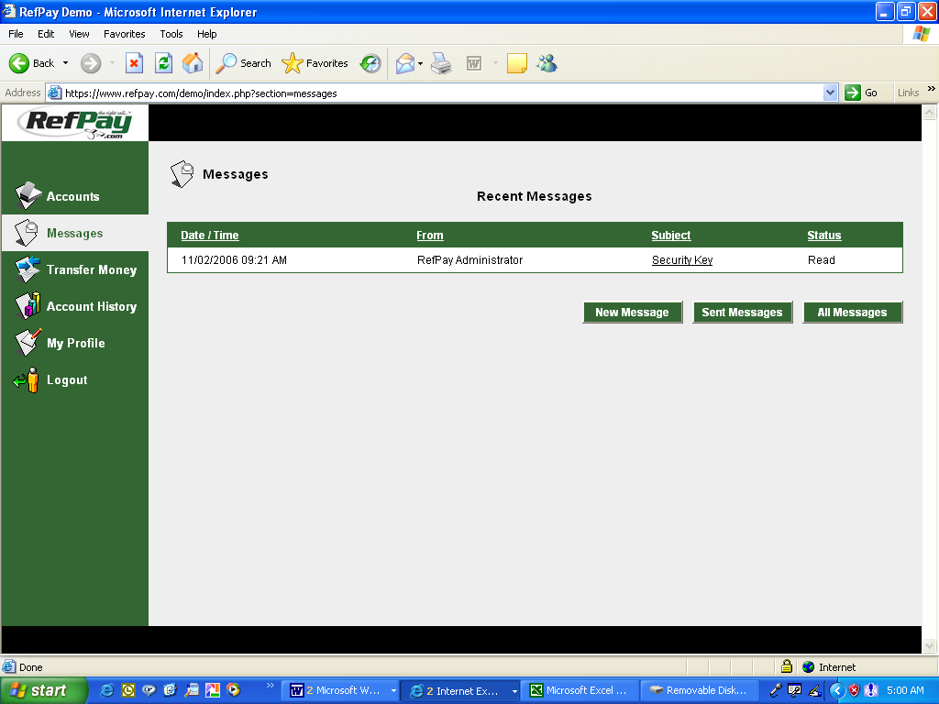
To send a message.
Click Messages link.
Click New Message.

This screen will appear.
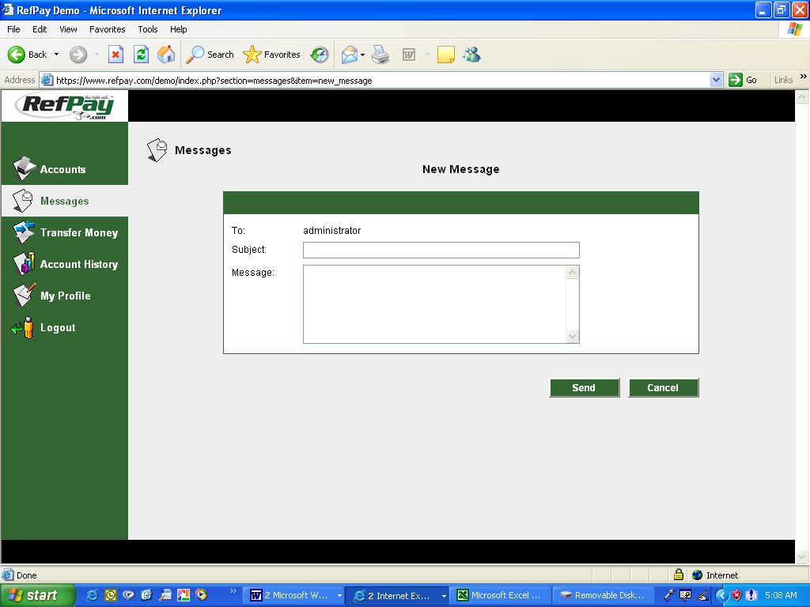

Write your message and then click send. The administrator will respond through the messaging system.

  - Receiving a Message

Receiving a message from the RefPay Administrator is easy. Click on the Messages Tab. Then on the Subject line link you want to read.
To read a message.
Click Messages link.
Click the link you want to read.

Your message will appear for you to read. The RefPay administrator will communicate with you through the system.
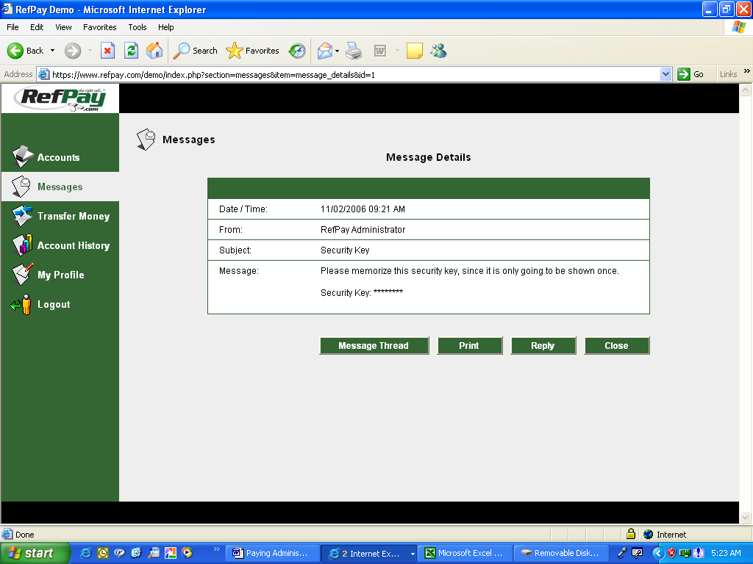

- Transfer Money
  - Access Your RefPay Money

There are three ways to access your RefPay money.

- Funding your RefPay Debit Card.
- Electronically Transferring Funds to a Bank Account (EFT)
- RefPay corporate mails you a physical check.

Every time money is transferred to and from the RefPay system, the electronic ACH banking network charges fees. RefPay’s philosophy is to provide our service FREE of charge. However, we have set up the following parameters to ensure we at least break even on a per transaction basis.
Fee Schedule
RefPay Debit Card = FREE
*EFT Funds to Bank = FREE
Mail a check = $3.00

*1 FREE EFT pr Month $2.00 charge after 1

If you’re like us at RefPay and love FREE, use your RefPay Debit Card or disciple yourself to electronically transfer funds once per month to avoid fees.

4.2 RefPay Debit Card

4.2.1 Getting a RefPay Debit Card

RefPay Debit Cards can be used at any location that accepts MasterCard. MasterCard is accepted at over 22 Million locations and at any ATM in the world. Using your RefPay debit card is an excellent way to track officiating expenses and receive instant payment for your services. A one time charge of $3.95 pr card will be assessed to cover the cost of issuing a card.

Obtaining a RefPay Debit Card is easy. Go to RefPay.com, click on the Accounts Tab, click on the Sign Up link. Fill out the form. You card will arrive in 7 – 10 Business Days.
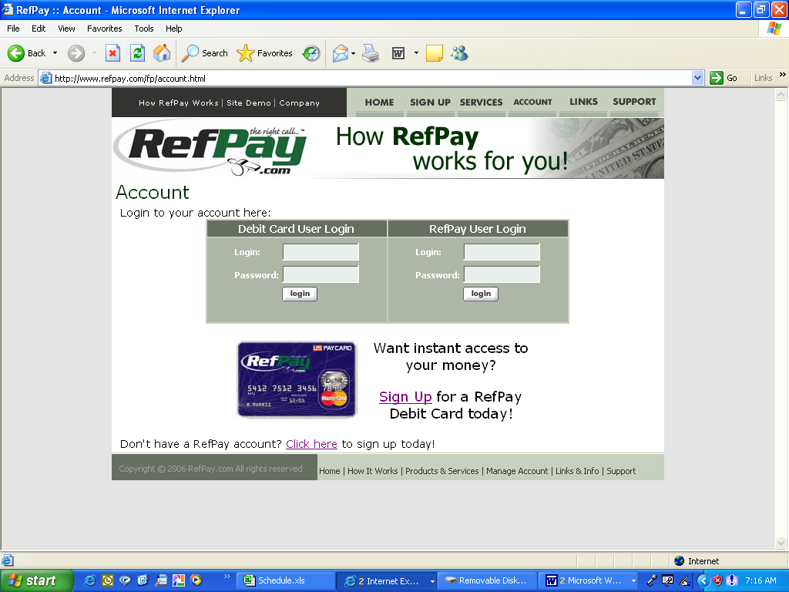

Get a RefPay Debit Card
Go to RefPay.com
Click Account Tab
Click Sign Up link

**** You must have a RefPay account before you can Sign Up for a RefPay Debit Card ****

4.2.2 Important Card Reminders

Using your RefPay Debit Card is FREE as long as you use the card on a NON-PIN transaction basis. When making any purchase, always run the transaction as a CREDIT. The ACH banking network charges companies that issue debit cards each time a transaction is run as a DEBIT. If the transaction is run as a CREDIT the merchant pays the ACH network charges. Therefore, if you run a transaction as a DEBIT charge the transaction fee will be passed on to you. However, if you run the transaction as a CREDIT charge the transaction will be FREE.

RefPay Debit Card funding is done by the user. It’s up to the user to determine the amount of money put on the Card. Users are not required to put their entire RefPay account balance on their RefPay Card. The maximum users can fund is determined by their available balance.

    - Funding Your RefPay Card

Funding your RefPay Card is easy. Click on the Transfer Money Tab, then on the Fund RefPay Card.
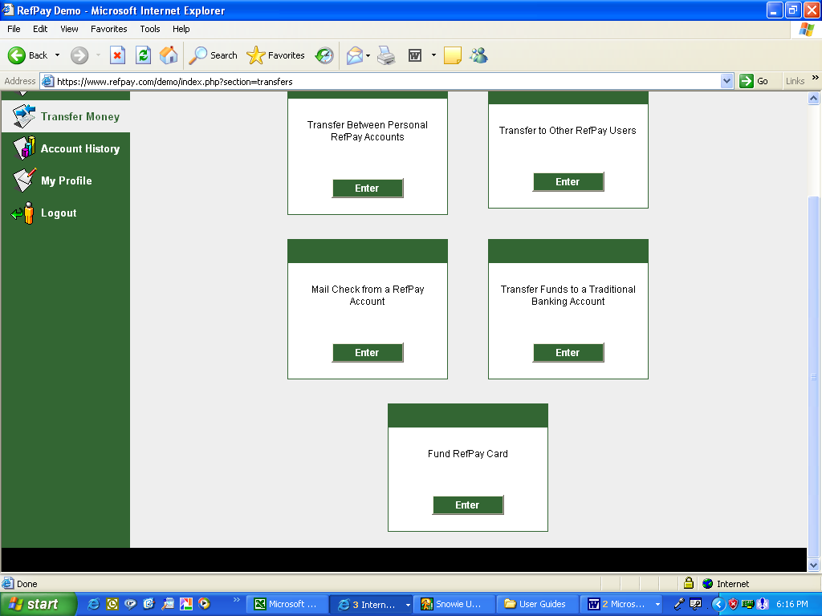
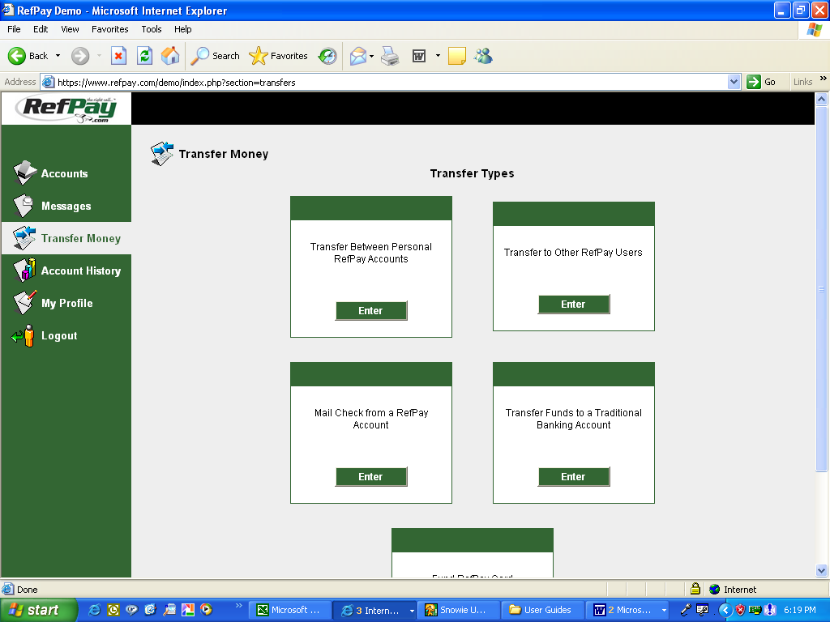

Fund RefPay Card
Click on Transfer Money
Click on Fund RefPay Card

The following form will appear. Fill it out, click continue to confirm the transaction and then submit. Your card will be funded instantly for the amount you designated.
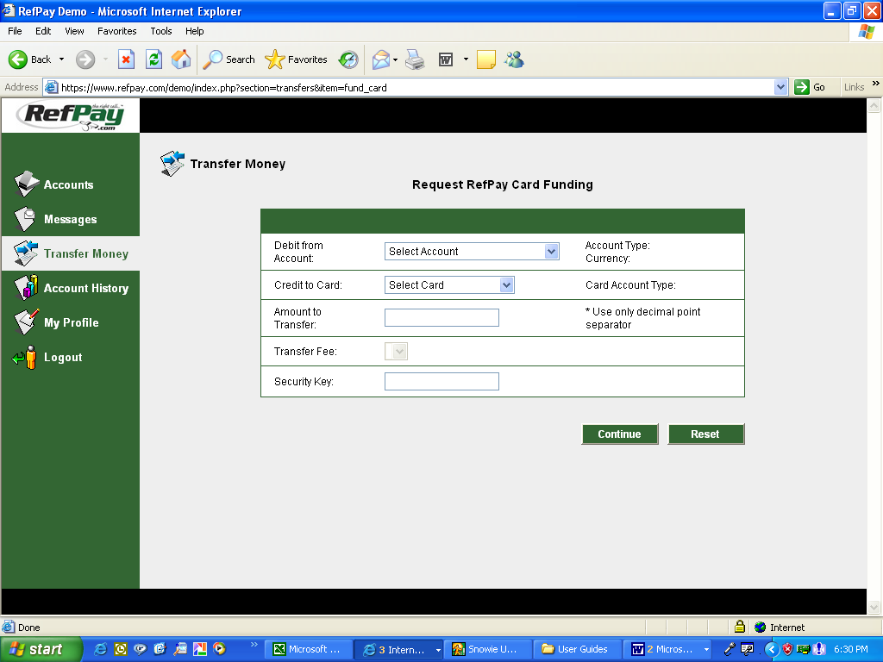

    - Getting the Balance on Your RefPay Card

Obtaining the balance on your RefPay Card is easy. Go to RefPay.com, click on the Accounts Tab and enter your Debit Card login credentials.

RefPay Debit Card Balance
Go to RefPay.com
Click Account Tab
Enter Login Credentials
Click Login

You will enter the RefPay Debit Card system and be able to access your balance and other valuable information.

  - Transfer Funds to a Bank Account (EFT)

Officials can transfer funds into their traditional bank account at anytime. Every time money is transferred to and from the RefPay system, the electronic ACH banking network charges fees. RefPay’s philosophy is to provide our service FREE of charge. However, to maintain viability we have limited the number of FREE EFT transfers to one (1) per calendar month. There is a $2.00 convenience fee for any EFT Transfer after the 1 FREE transfer. The maximum Officials can request to have sent to their bank account is determined by their available balance

To transfer funds to a bank account, select the Transfer Money Tab, then select Transfer Funds to a Traditional Bank Account.
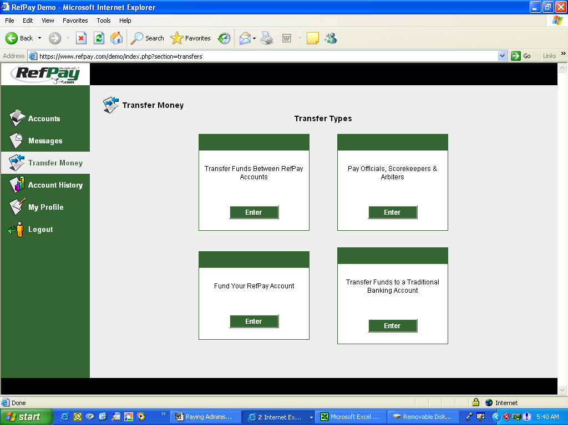
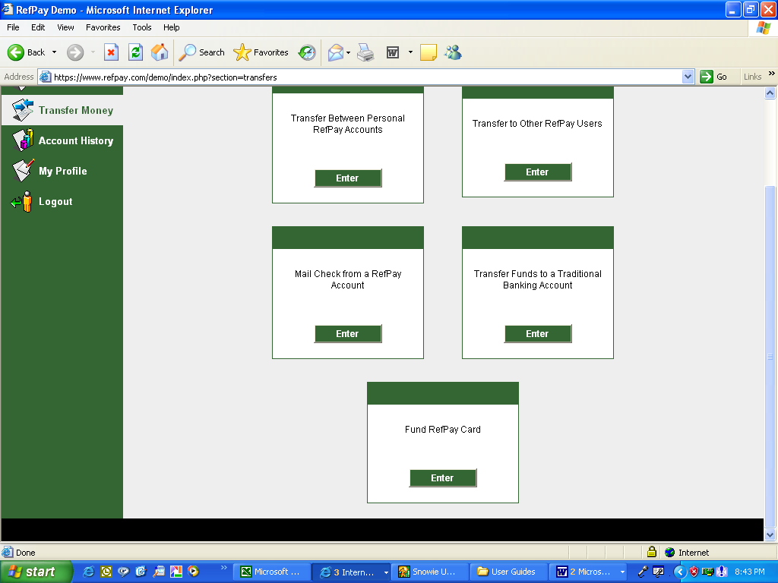

Transfer to a bank account
Click Transfer Money
Click Transfer Funds to Bank

Fill out the form, click continue to confirm the transaction and then submit.
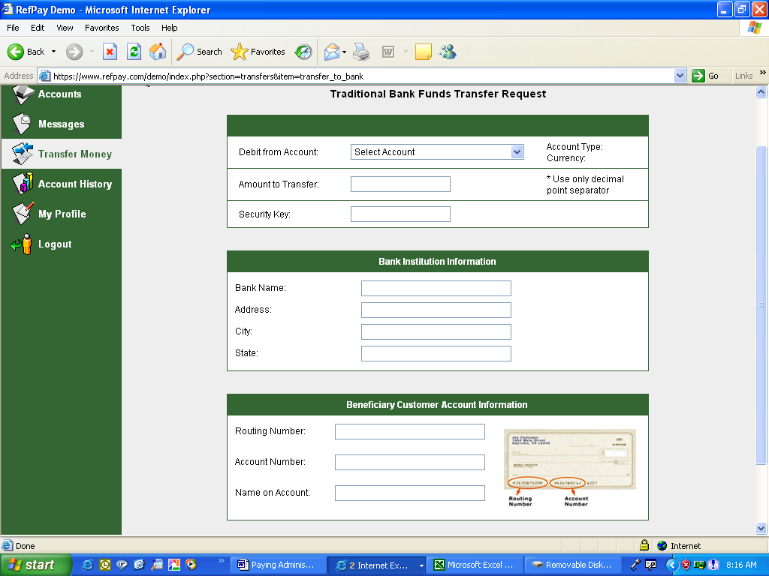

Your bank account will be credited within 2 – 4 business days depending on the ACH network.

Your bank account will be credited within 2 – 4 business days depending on the ACH network.

  - Request a Physical Check

Officials can have a physical check mailed at any time. The maximum Officials can request is determined by their available balance. Writing and mailing physical checks is costly and time consuming. There is a $3.00 charge to cover the costs associated with this type of transaction.

To request a physical check, select the Transfer Money Tab, then select Mail Check from a RefPay Account.
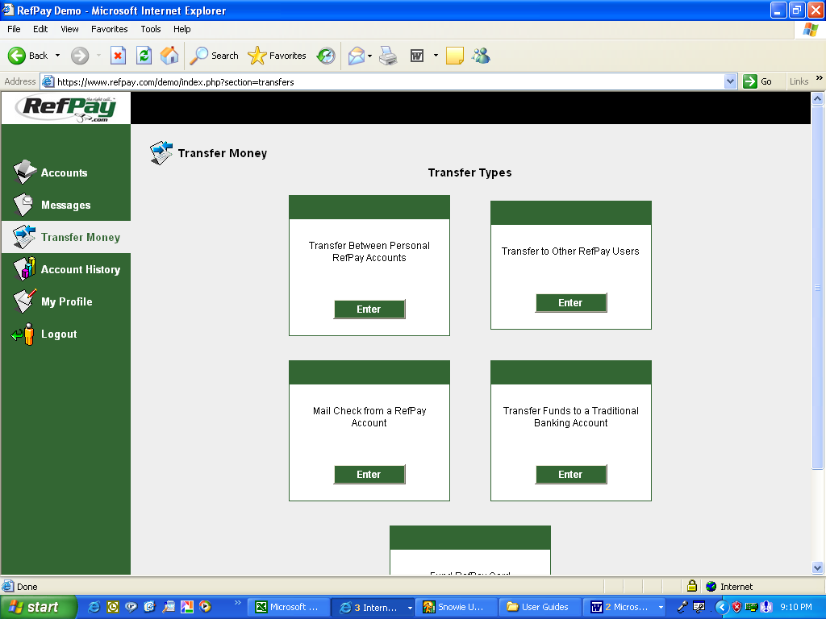
Request a Check
Click Transfer Money
Click Mail Check

The following form will appear. Fill it out, click continue to confirm the transaction and then submit. Your will receive a check within 3 - 5 business days.
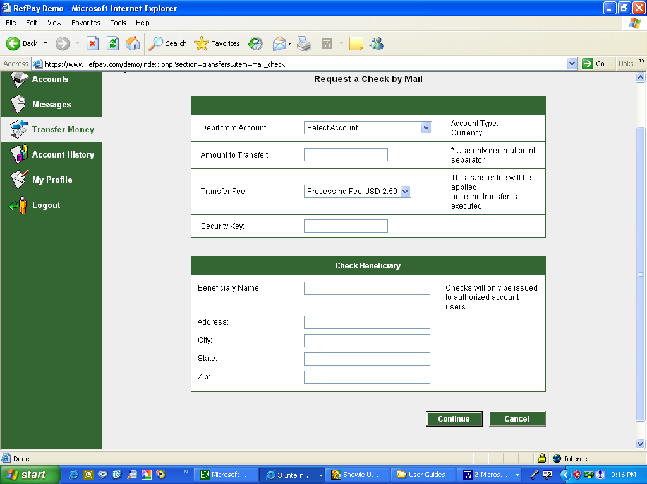

  - Transfers – Personal RefPay Accounts (Owned by same individual)

For Officials who have multiple RefPay accounts, you can transfer money between them at your discretion. To do this select the Transfer Money Tab, then select the Transfer Funds Between RefPay Accounts Option.
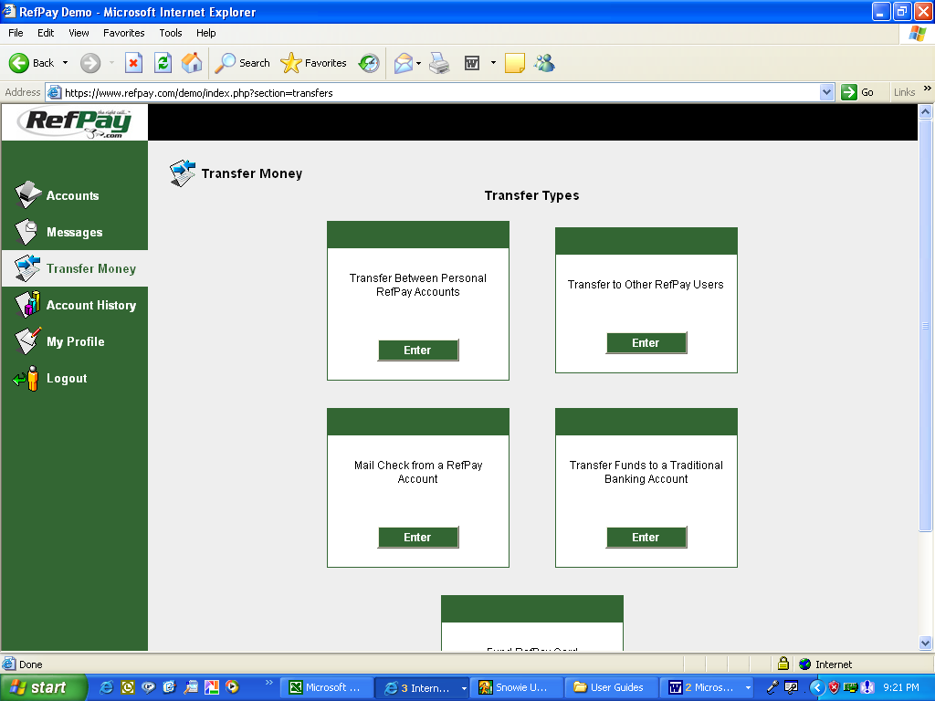

Transfer between accounts.
Click Transfer Money.
Select Transfer between RefPay account options.

Fill out the form, click continue to confirm the transaction and then submit.
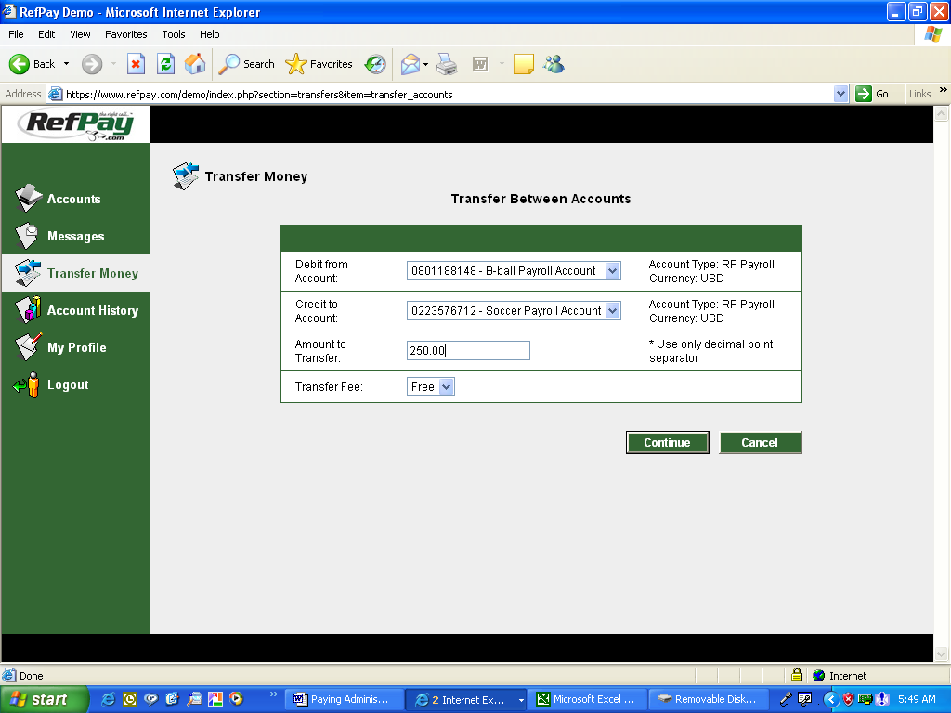

The money will be instantly transferred to your other account.

4.6 Transfers – Other RefPay Users

Paying other RefPay Account holders is easy through the RefPay system. There is a .50 cent transaction fee for this transaction. Officials may utilize this option to reimburse mileage, receive per diem, pay camp fees or for any other reason money changes hands. To Pay another RefPay Account, select the Transfer Money Tab. .

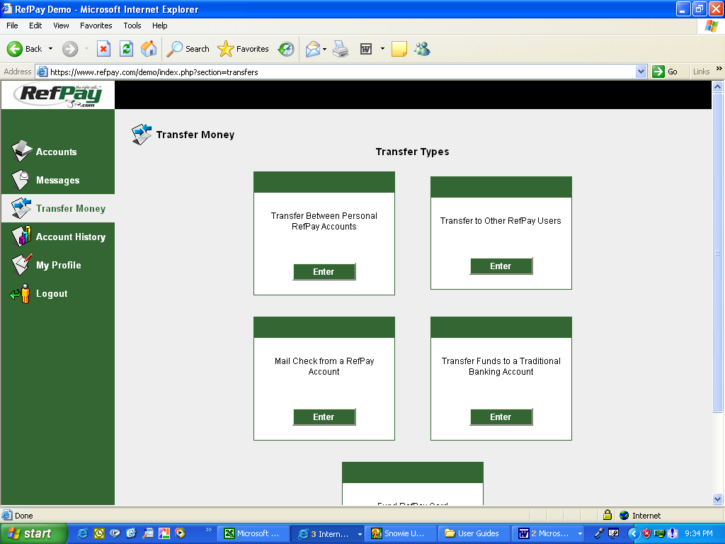

Transfer to Another RefPay Account
Click Transfer Money
Click Transfer to Other RefPay Users

You must enter your Security Key to proceed with the transaction.

Fill out the form, click continue to confirm the transaction and then submit.
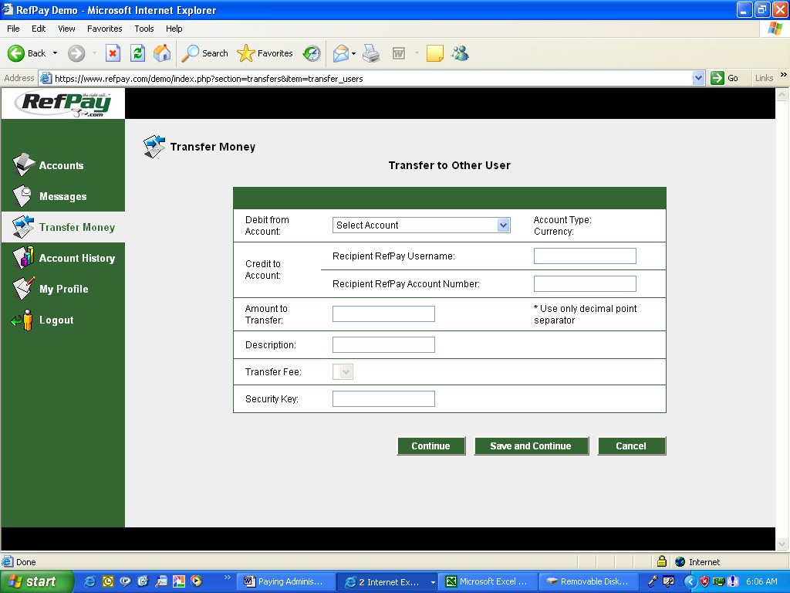

You will need the Officials RefPay username & RefPay account number.

You must enter your Security Key to proceed with the transaction.

The Official will be paid instantly into their RefPay account.

- Account History
5.1 Payment Verification

To verify payments have been made to your RefPay account, select the Accounts Tab, then select the account link.
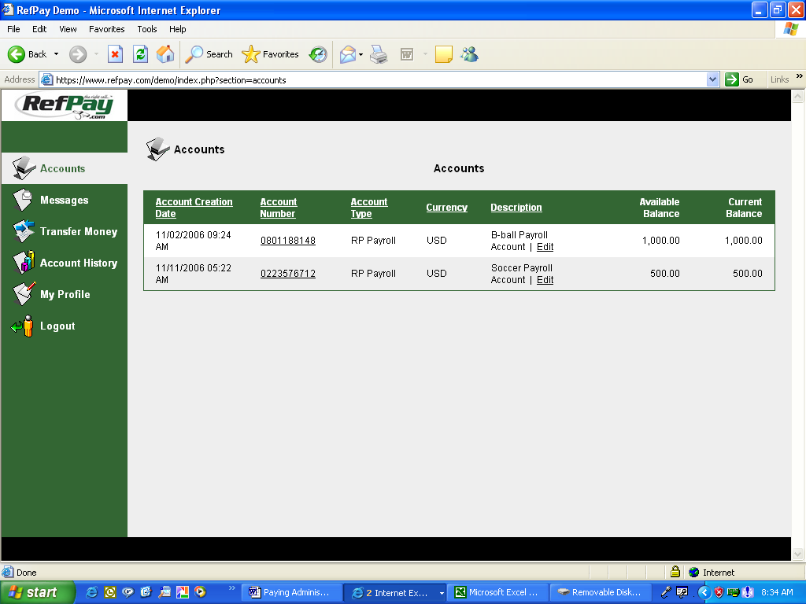
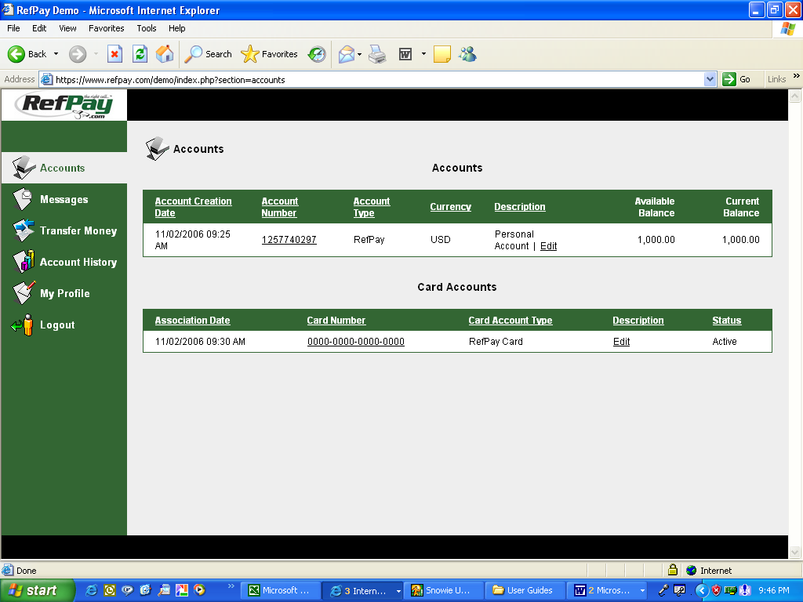
Payment Verification
Click Accounts
Click on the Account link.

The Account Details page for the selected account will appear. You can search for payment verification by date, description or status.
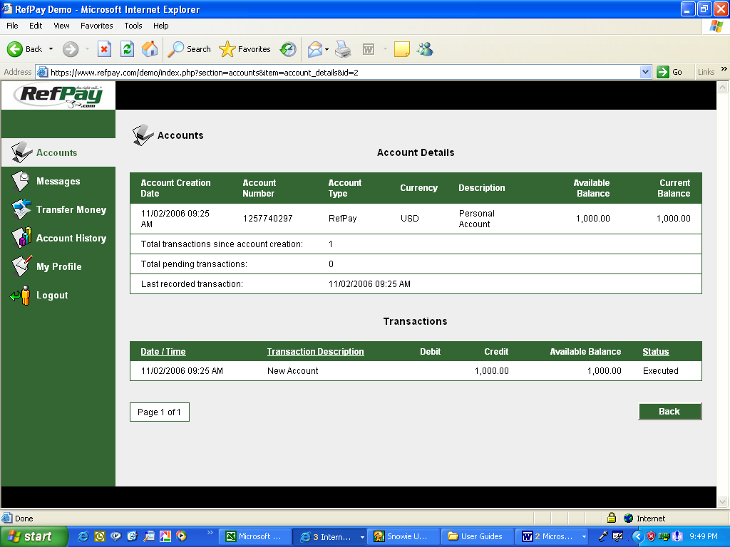

5.2 Audit Information

RefPay’s accounting system records every transaction performed on any account. To obtain a detailed listing of each transaction, select the Account History Tab, then select All Accounts Transactions.

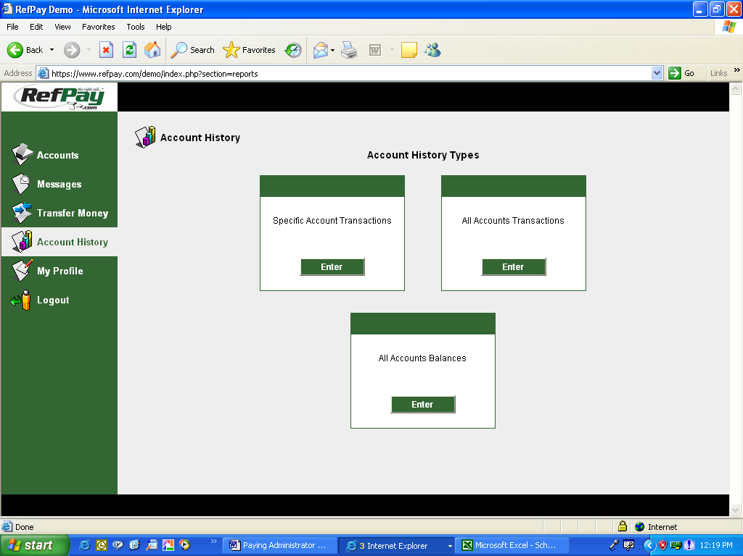

Account Audit Detail
Click Account History
Click All Accounts Transactions

A detailed breakdown of all account transactions will appear. For Officials with multiple accounts, a detailed breakdown of each account will appear.

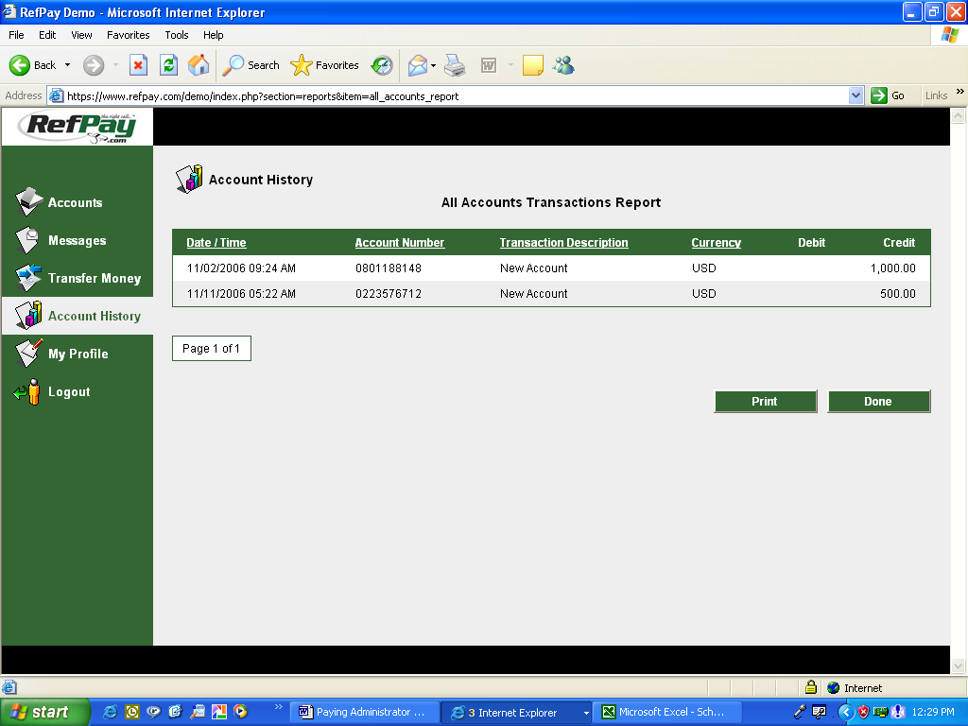

  - Transaction Search

RefPay users can easily search for and find any transaction that has affected their account. To search for a specific transaction, select the Account History Tab, then select Specific Account Transactions.

Specific Transaction Search
Click on Account History
Click on Specific Account Transactions.

A customized search screen will appear. Enter your search criteria and then select Generate. .
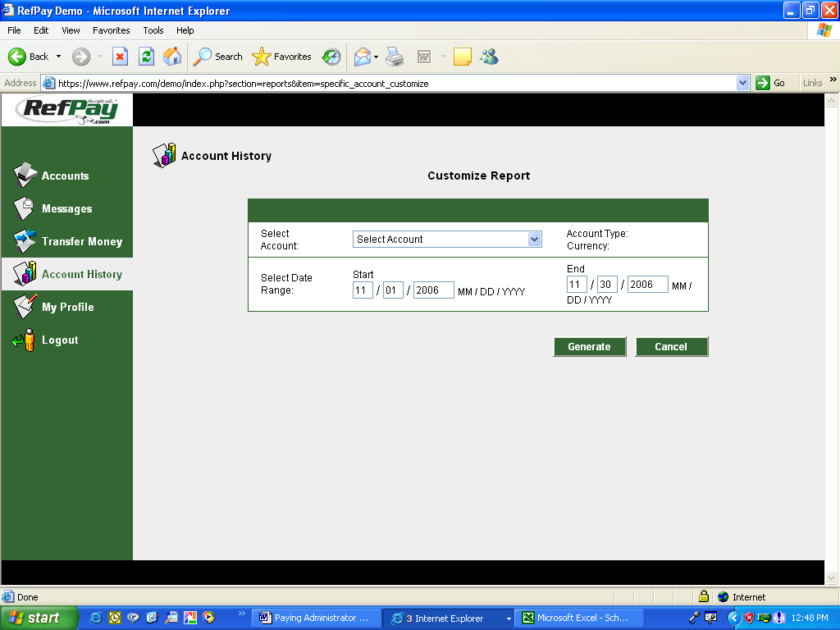

A report will generate with the criteria you selected.
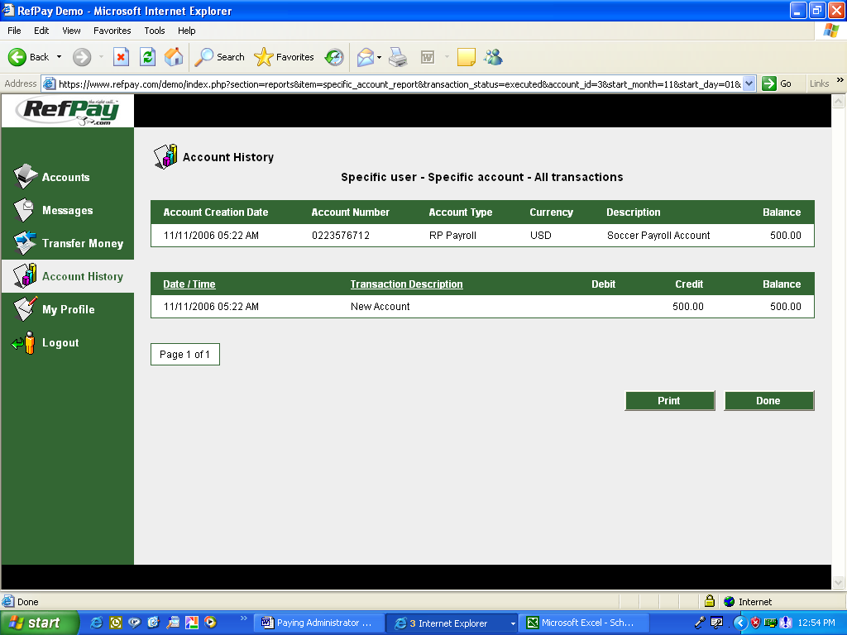

5.4 Account Balance Inquiries

RefPay users can get an account balance at any time. Users with multiple RefPay accounts will get a combined balance for all of their accounts. To get an account balance, select the Account History Tab, then select the All Accounts Balance.
Account Balance Inquiry
Click on Account History
Click on All Accounts

A report showing all you combined accounts balance will appear.

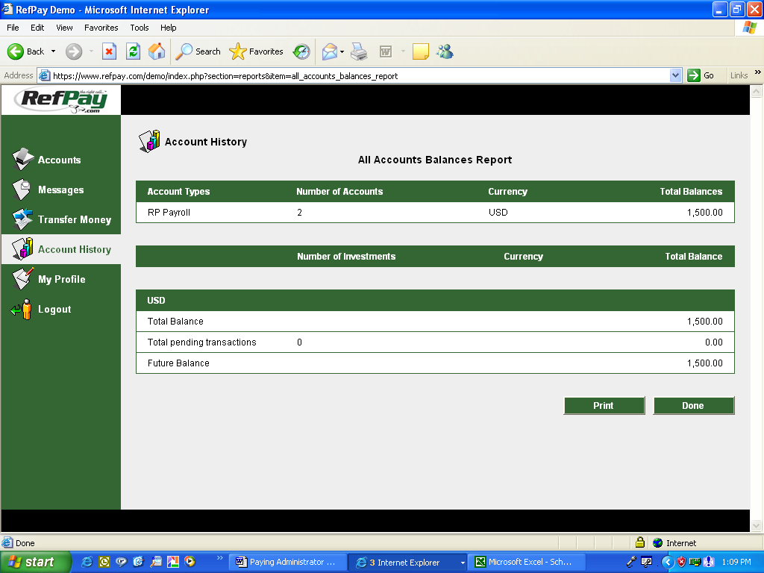

- Account Profile
6.1 Change Password & Profile

RefPay users can modify their profile at any time. To modify a profile – Select My Profile Tab, Review the information on the screen and scroll to the bottom and Select Modify.
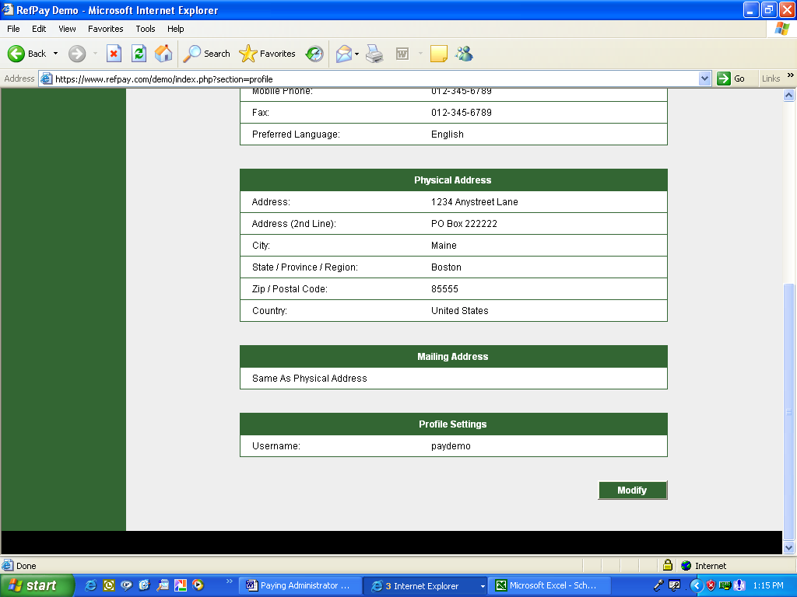
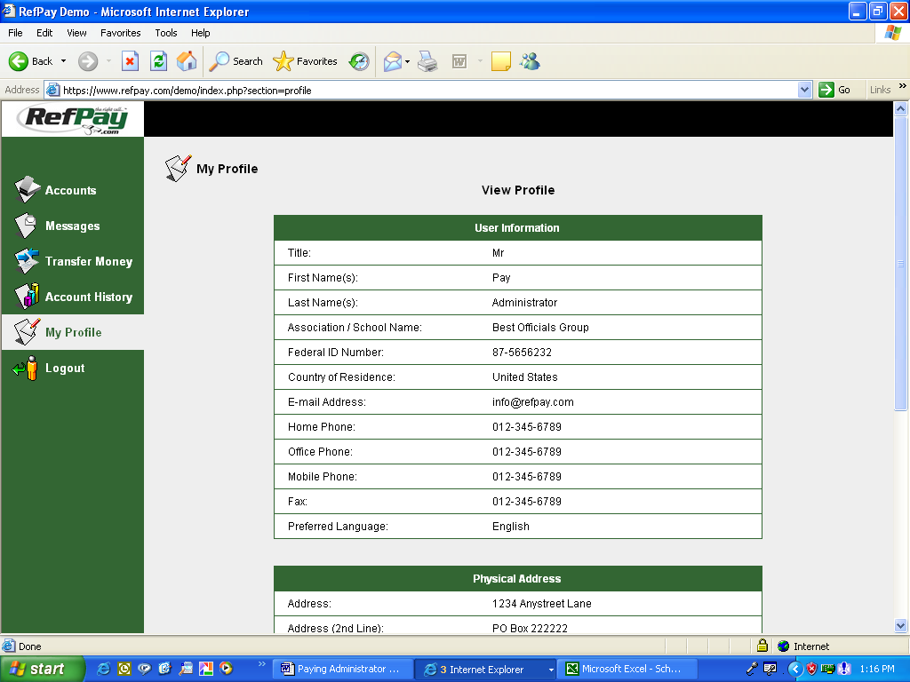
Change Password
Click My Profile
Click Modify

Modify and Update your information. Click Save when finished.
